LEARNING JOURNAL
February 8th
Today I started working on my first package that is the player movement. I watched tutorials on how to create a moving character and I was able to do it. I came across a problem where I wanted to move my character to the side so that he can look at the side, but it didn’t work so I found another tutorial and used it. I was then able to create a basic movement for my character.
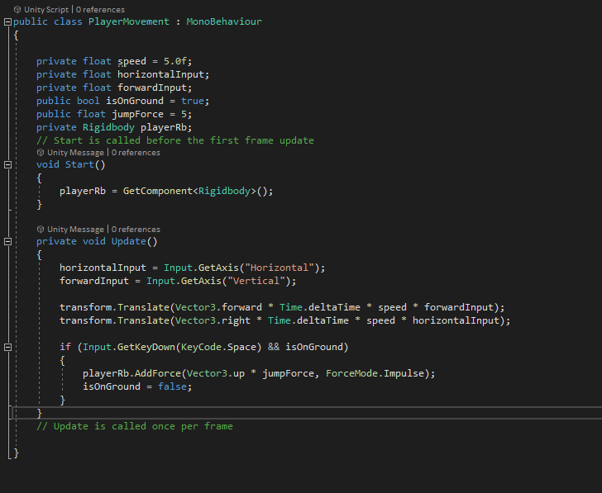

February 22nd
Today I decided to start working on a coin script. The coin script I originally created didn’t show any ui on the top of the screen so I decided to try to implement a coin script where you can pick up a item and it can have ui on the top left that counts how many items you pick up. 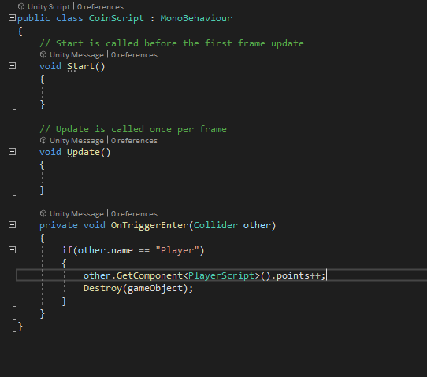

March 1st
Today I decided to make a script that allows the enemy to follow you if you get too close. This reason is because some people that want a script that has an enemy chasing you. I came across a problem that when I finished the code the player would get close to the enemy and nothing would happen. I then remembered that I had to add a rigidbody to the enemy and it started to work.
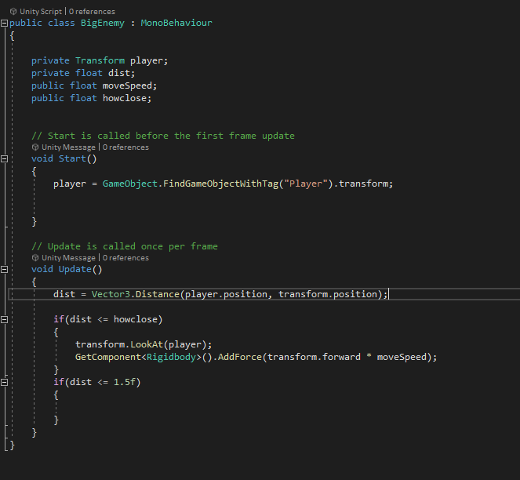

March 15th
Today I decided to make a main menu that allows you to go between the option menu and main menu and if you do not want to play anything then there is a exit button too. When I was doing this, I forgot to go in on build settings and add the scenes.
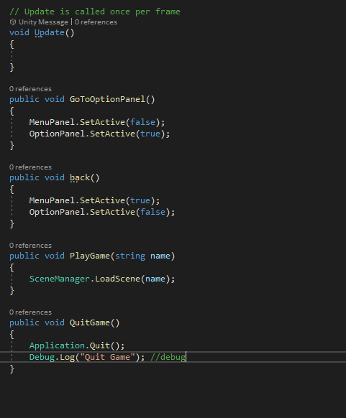

March 22nd
Today I decided to make a enemy patrolling script. This script allows anyone to grab and drag it into their work. All they need to do is make 3 waypoints by adding 3 cubes and attaching it to the script.
